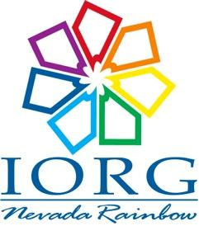
Rainbow Trails Advertisement Order Form
Camp Discount Orders
Grand Assembly of Nevada,
International Order of the Rainbow for Girls

Name of Purchaser: _______________________________________Assembly: __________
Address: __________________________________________________________________
Phone: ___________________ Email: _________________________________________

- Circle Selection
Full Page (4.7’ x 7.5’)………………………………………………………………………………………………. $156.00
Half Page (4.7’ x 3.7’)……………………………………………………………………………………………… $104.00
Quarter Page Vertical (2.5” x 3.7”)………………………………………………………………………….… $58.00
Quarter Page Horizontal (4.7” x 1.7”)……………………………………………………………………….. $58.00
Eighth Page (2.5” x 1.7”)…………………………………………………………………………………………… $29.00
- Who will design your ad?: (Circle One)
- You are!
  - Email, burn to CD or attach your advertisement to this order form.
- Trails design team?
  - Give specific instruction and request in this space.
________________________________________________________________________________________________________________________________________________________________________________________________________________________________________________________________________________________________________
Attach your check payable to Nevada Grand Assembly and either bring this form to Rainbow Camp or mail to: Kelly Potts
Director of Public Relations
9395 Oakley Ct.
Reno, Nevada 89521

Thank you for supporting Nevada Rainbow, a nonprofit 501(c)3 organization.

